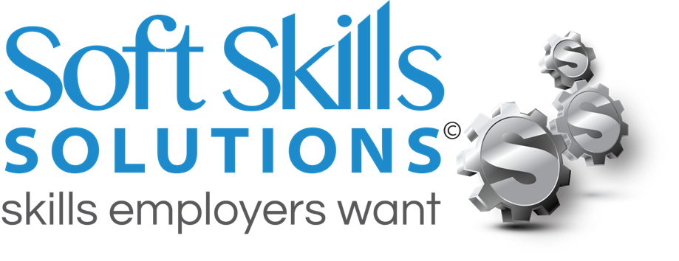
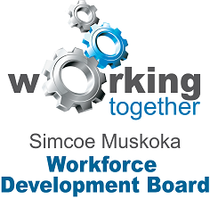

This certifies that

Has successfully completed
Soft Skills Solutions
Employability Skills Training Program
Developed by Simcoe Muskoka Workforce Development Board

____________________________
Trainer Signature

July-25-17
Date

